RRS Guide
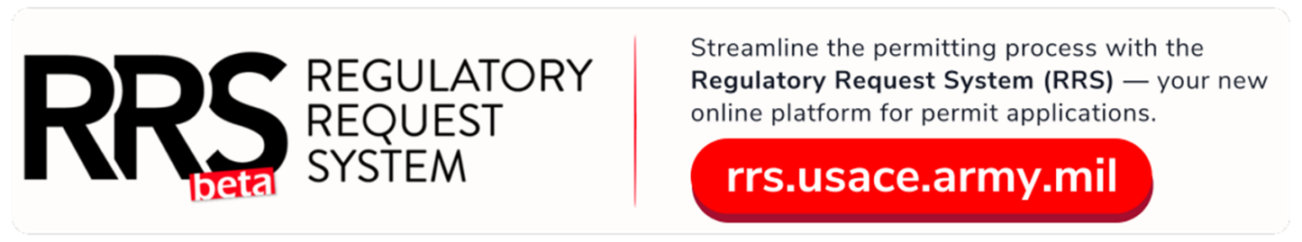
- Go to RRS web page https://rrs.usace.army.mil/rrs – click “Apply for Permit,” “Jurisdiction,” or “Report a Violation” depending on your needs
  - “Apply for Permit” for Permit Applications, Pre-App Applications, or Jurisdictional Determinations
  - “Report a Violation” if you would like to report a potential violation to the Rock Island District.
- 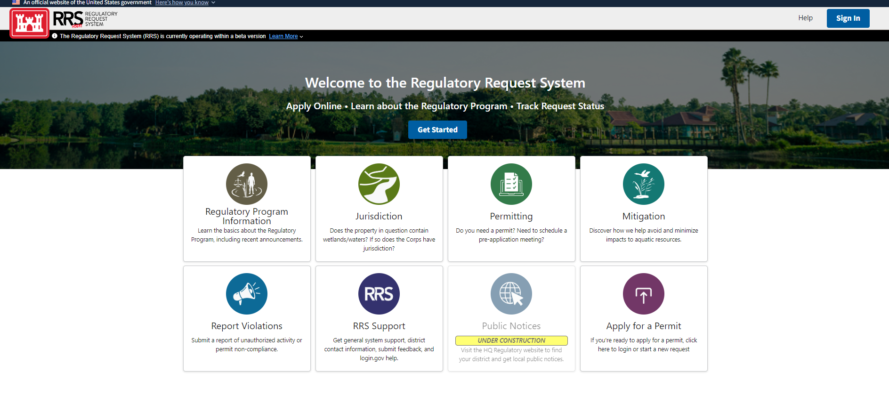Now click the “Login” button, which will take you to login.gov. If you already have an account, you may use this account. If you do not have an account, please create one.
  - Note: if you work for a government entity, you will most likely need to create a new account with a personal email if applying as an individual, not a company
Login.gov (note that this is a test example, but the live site will look almost identical)
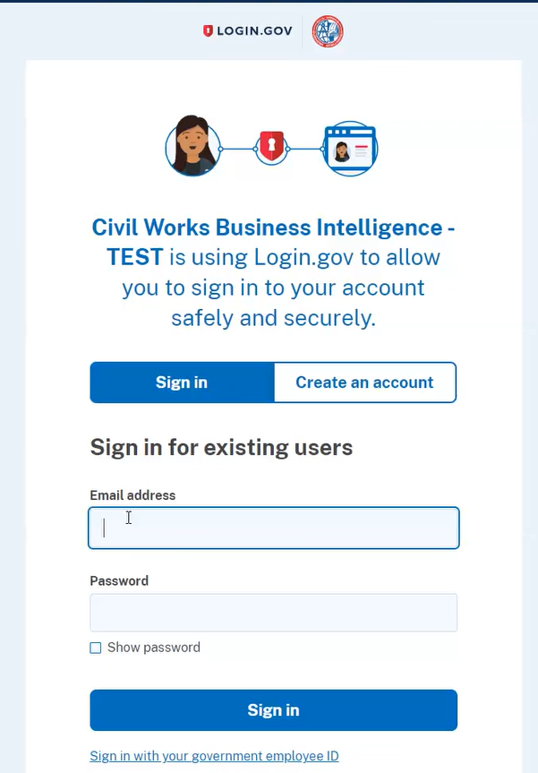

Helpful Information To Get You Started:
- If you have submitted applications as both the applicant and agent, you will need to make sure you are submitting under the correct profile. Please check this at the top.
- Once you submit your application, you CANNOT change or update it. You can only edit your application when it is a draft BEFORE you submit. If your project manager from the Corps asks you for additional information later, you can submit that via email or mail.

- Choose one of these options once you are logged into the site
- 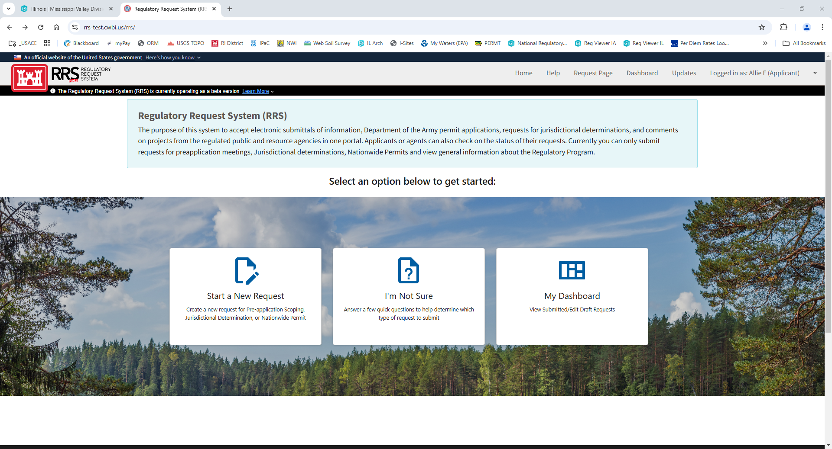
  - Start a new request – this is for a new project
  - If you are not sure what you may be applying for, you can click “I’m Not Sure” and the site will guide you with questions if you are not sure what you are needing.
  - “MY Dashboard” – if you have a request pending or submitted, you can view it here. Once submitted, you cannot edit but you can email your assigned project manager any new information. If you still have a “draft request,” you can continue to add documents and save as needed until you are ready to submit.

- If old file (project), you can add that information so we can associate the old and new project, if applicable. For example, an old project number for the Rock Island Corps of Engineers may look like OD-P-YEAR-XXXX or MVR-YEAR-XXXX. Please see below picture
- 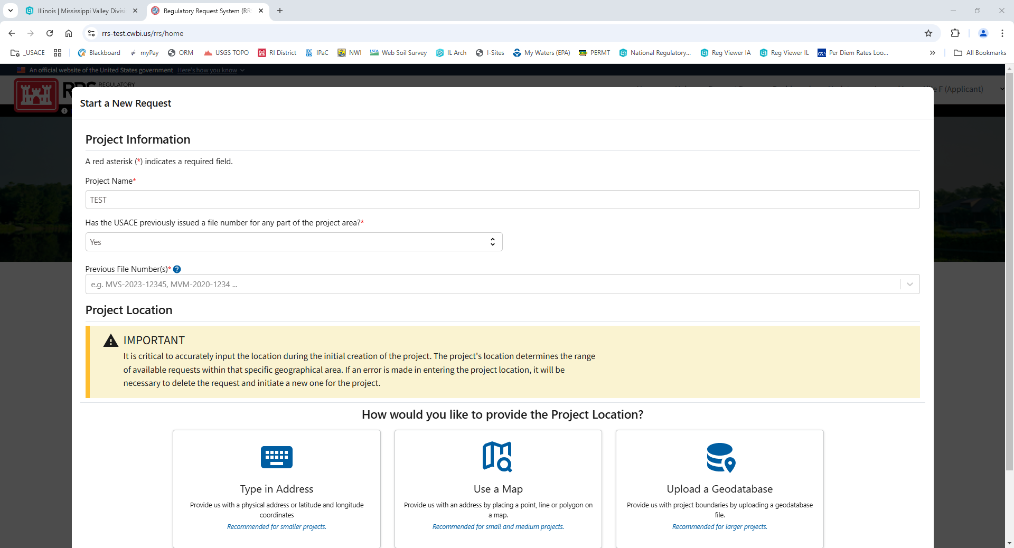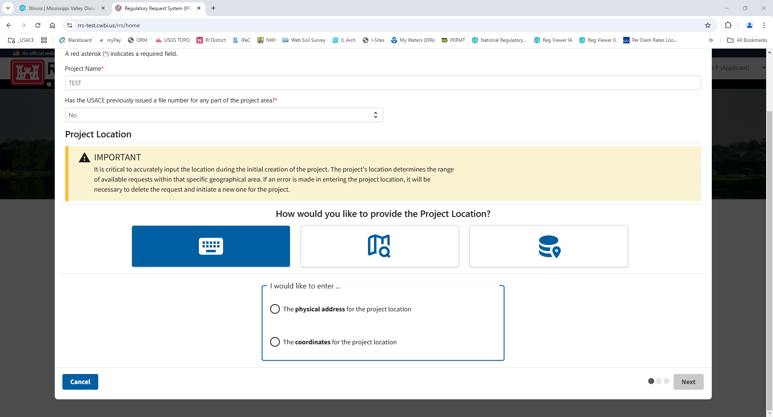
- Location - Use either a point or polygon to create your project area, or you can type in the Latitude and Longitude, or upload a geodatabase file. Please be as specific as possible.
  - If you are applying for a permit that takes up a large/ long area, please get the whole area included, as this will be assessed when reviewing your project for permitting.
    - For instance, if you are applying for a permit for a pipeline, please include the ENTIRE pipeline length/ area that you will be working, not only where your pipeline may cross a waterbody.
  - Make sure to include the unit of measure.

- If starting a new request, click the appropriate item
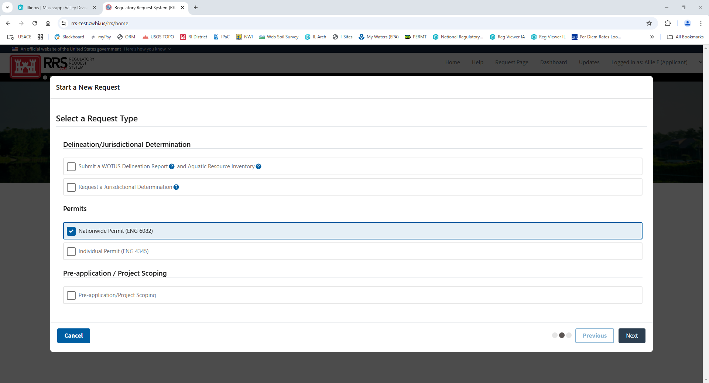
  - If you would like a “Jurisdictional Determination,” please choose this option. A jurisdictional determination is a process that we use to assess if the Corps of Engineers regulates a certain area that you identify – JDs can be “preliminary” or “approved”
  - Select ”Nationwide Permit” or “Individual Permit” if you are applying for a permit for a project.
  - Select “Pre-application/ Project Scoping” if you have ideas for a project, but need some guidance on things such as permit types, plans, location, etc.
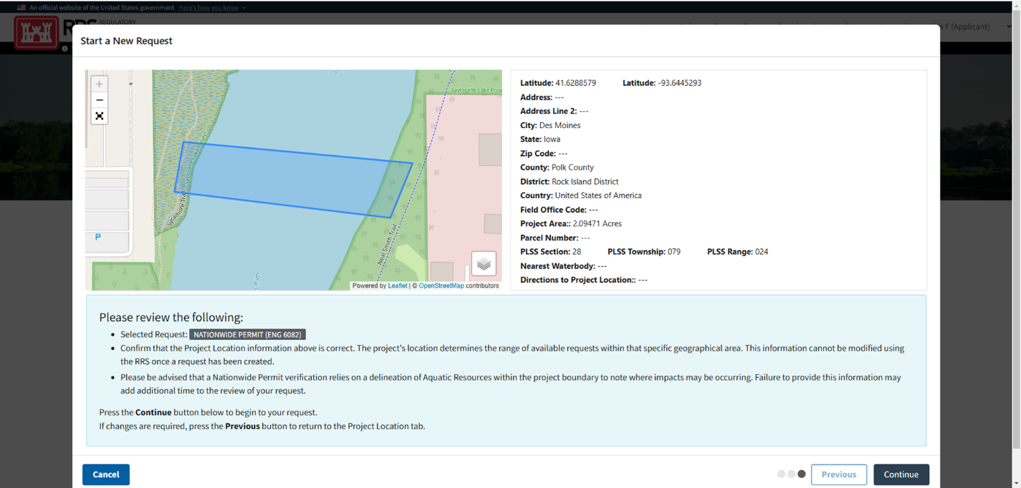

- Example Submission: Submit a “Nationwide Permit”
  - It will take you through all the tabs to the left
    - Instruction – explain delineation reports and jurisdictional determinations
    - Contact Information – Applicant, Agent ( can click “Use Profile Data” on the right hand side to pull from your profile instead of filling it in, if applicable
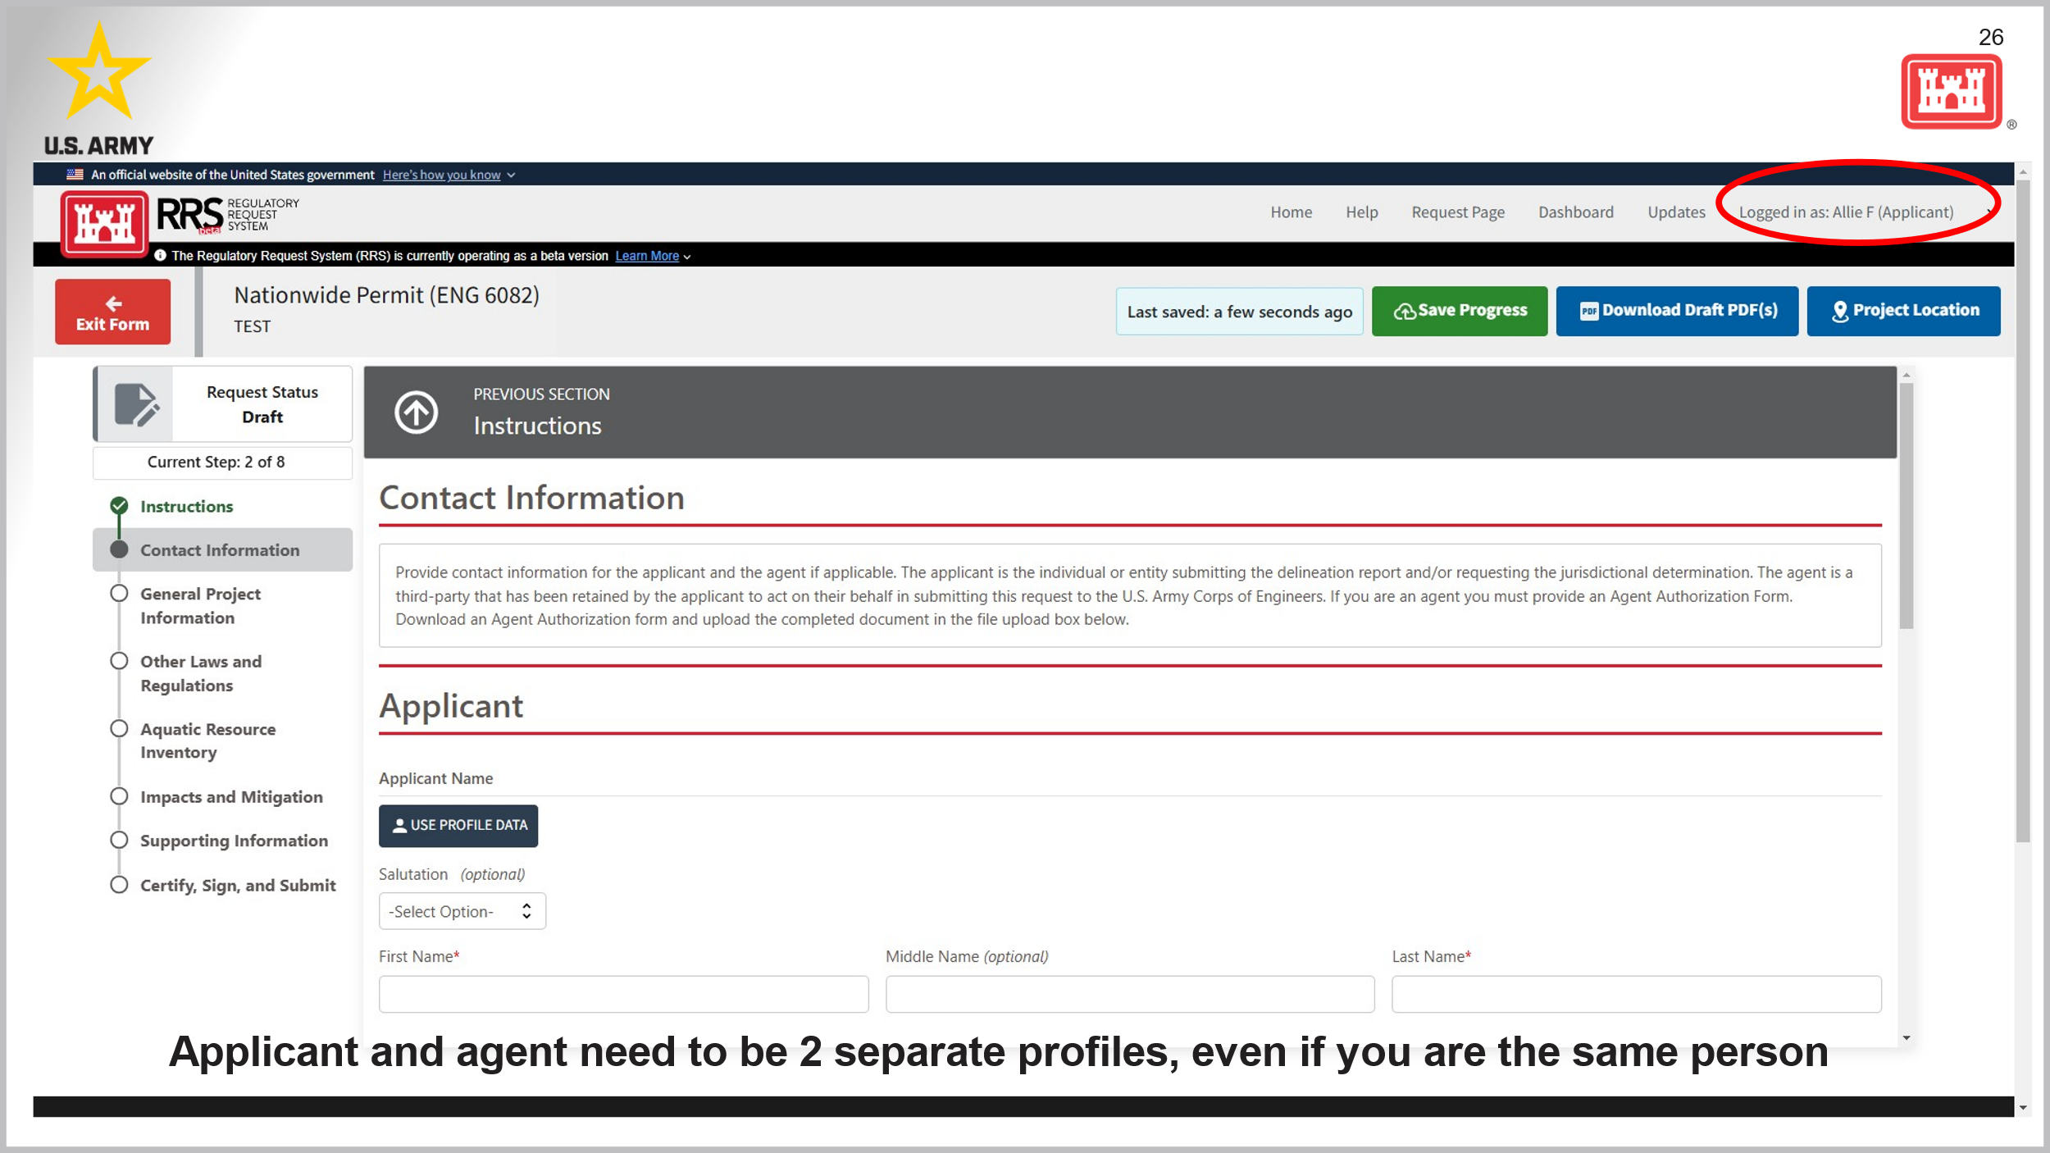
    - General project information – Name, reasoning for project, description, purpose
      - See picture below – read the descriptions of Section 404 and Section 10 and choose to the best of your ability
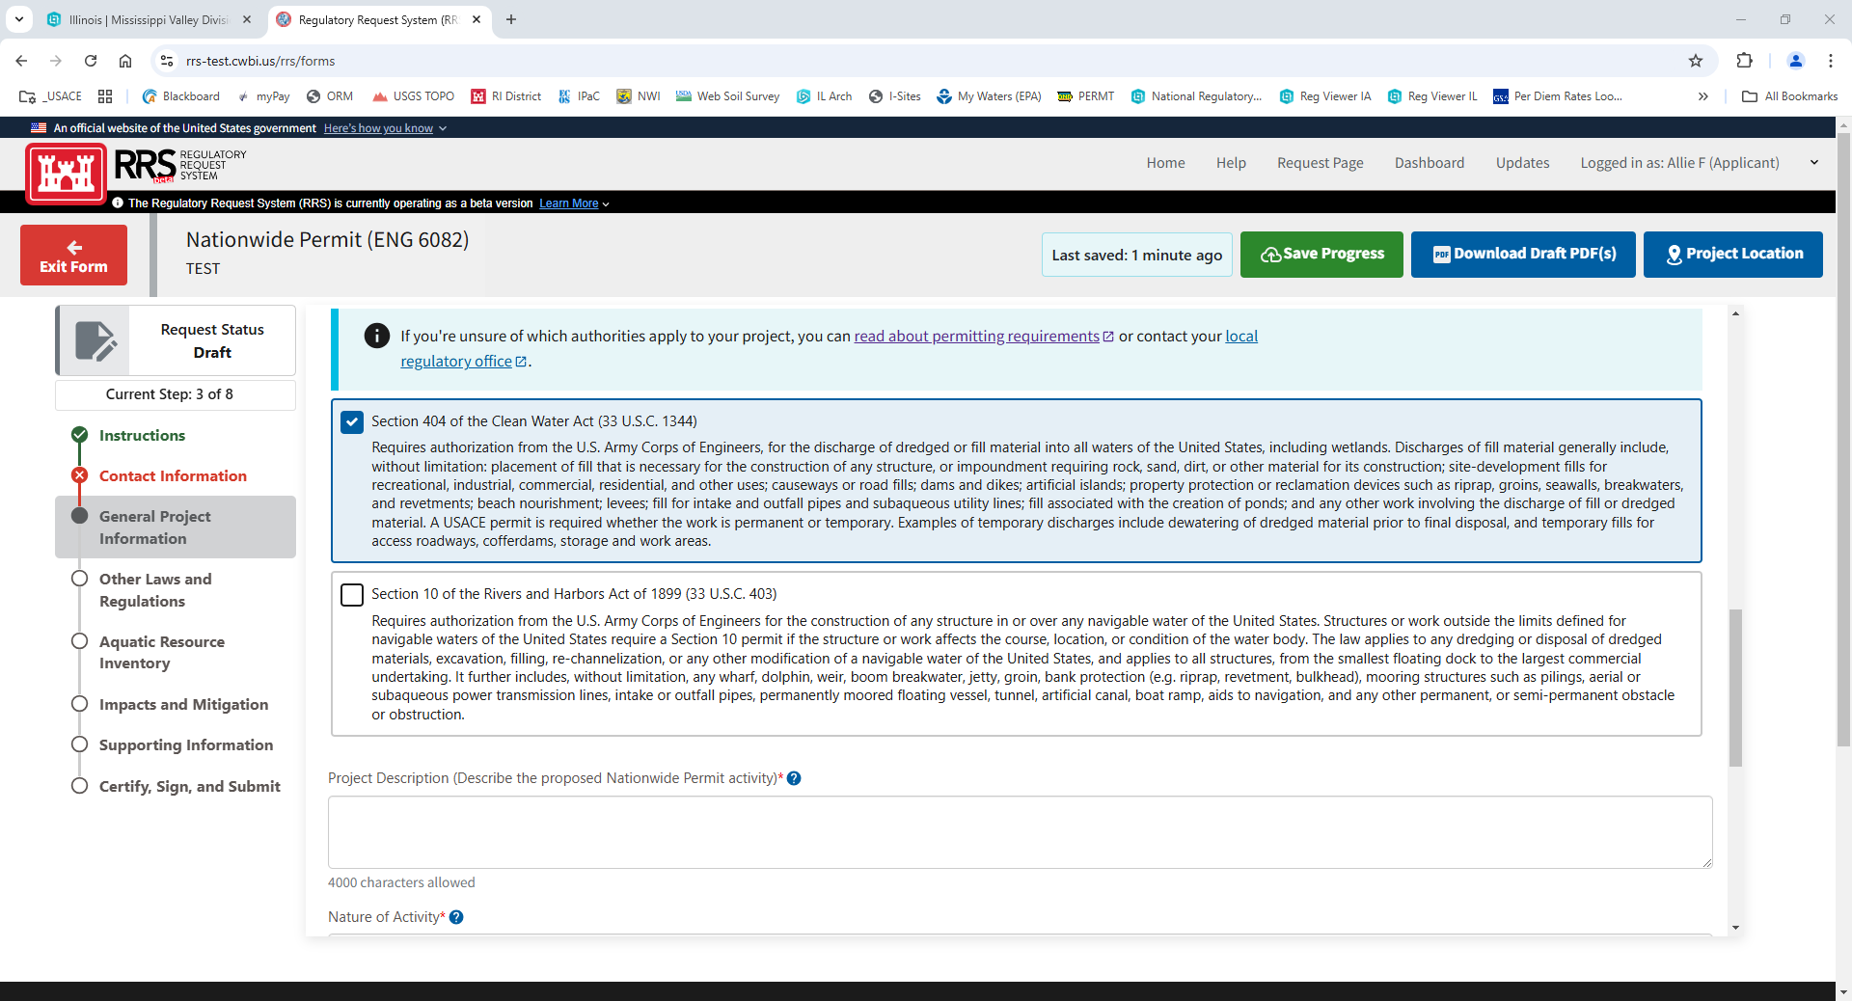
    - Other Laws ad Regulations – See pictures below - this section refers to Endangered Species, Historic Properties, or 408 (levees) in your potential project location area – if you have any information to provide on these topics, please add it (you can also upload any documentation you have on this in “Supporting Information” Section
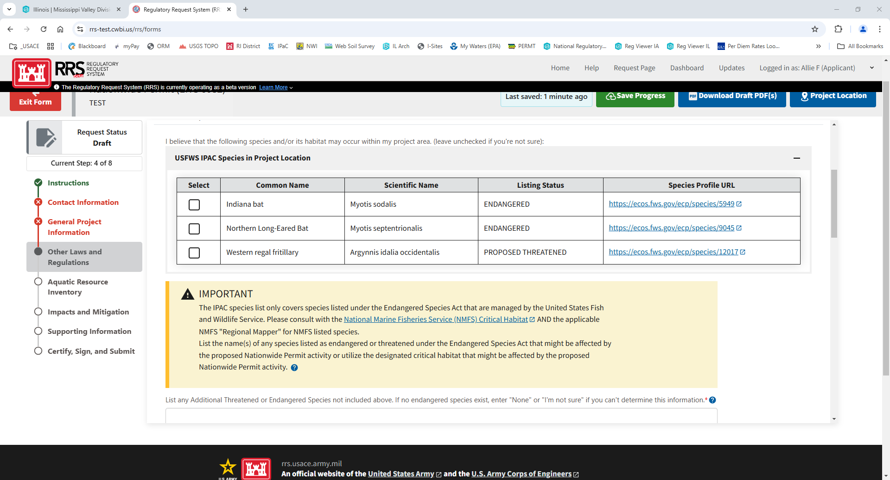
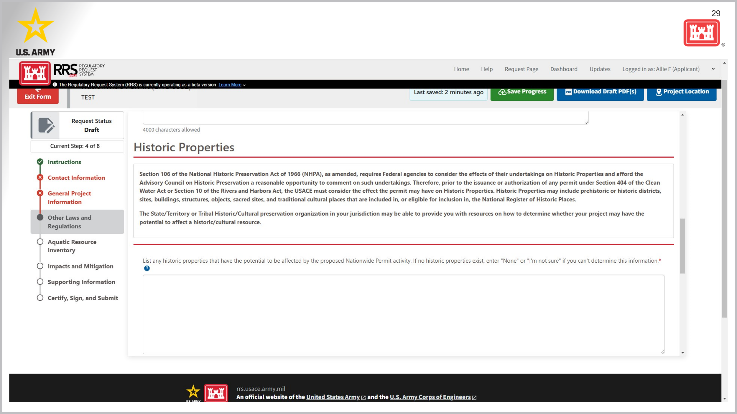

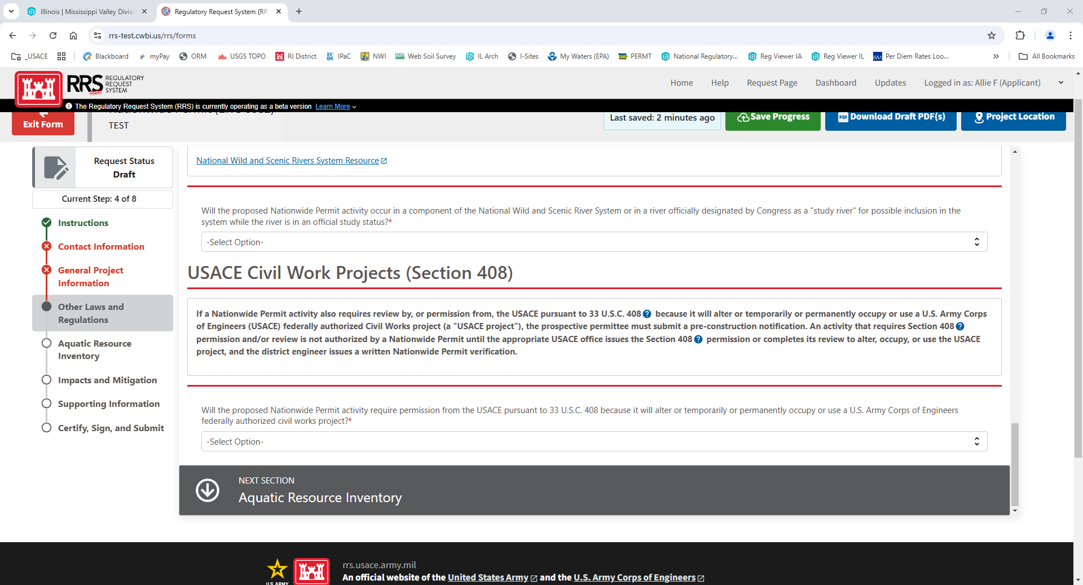
    - Aquatic Resource Inventory – what aquatic resources are on property
      - if you have delineation report available, please upload later in the “supporting documents” section– often, agents will have this – if you don’t, that is okay
      - You can upload this information in bulk or manually (see pictures below)
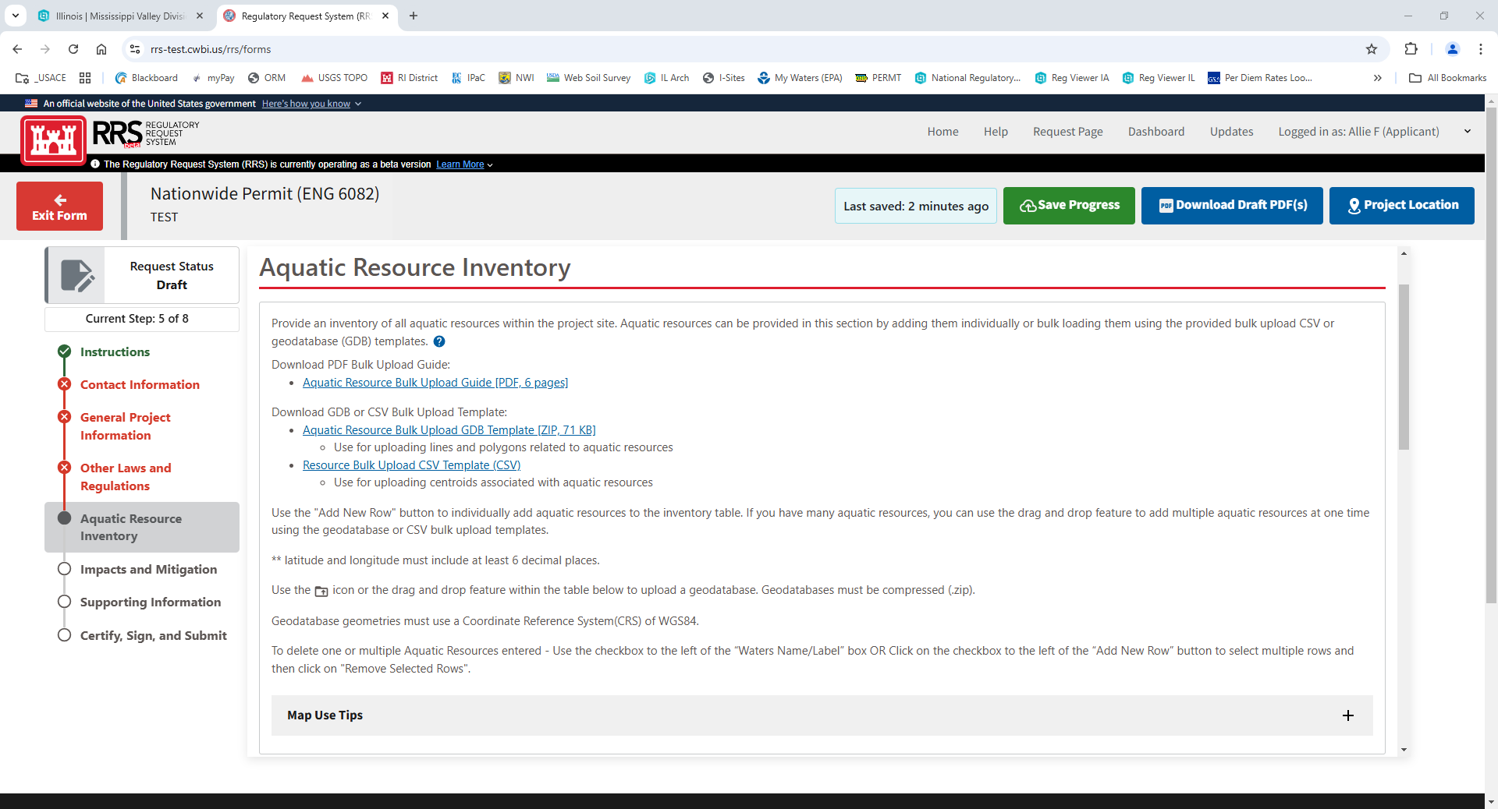
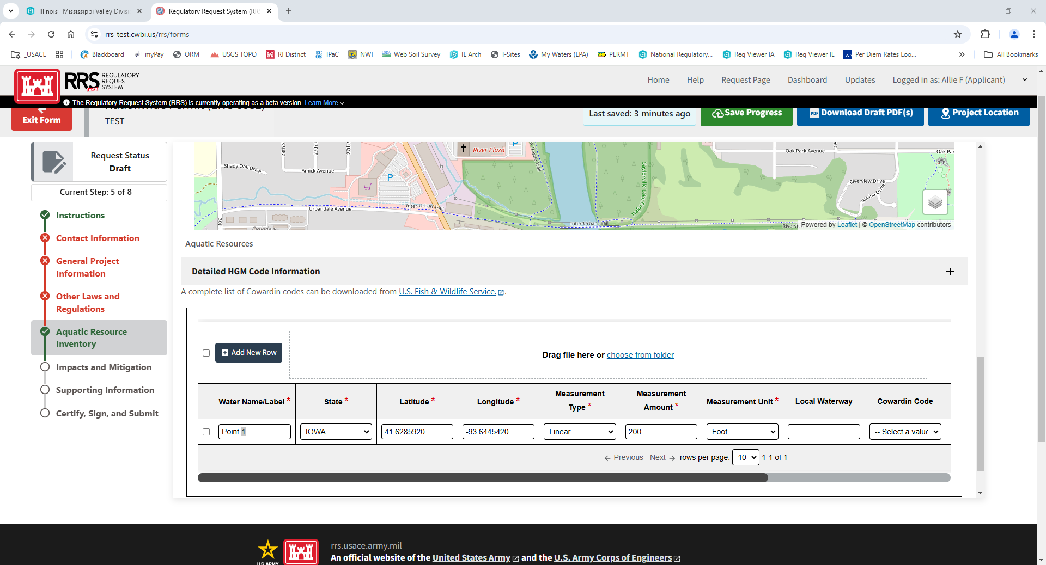
    - Impacts & Mitigation – impacts to waters of the U.S.
      - This information will be based on the aquatic resources you listed in the “aquatic resource” section – please put in the aquatic resource impacts to the best of your ability – you must put something into sections with an asterisk (*)
      - If you are above impacts of a certain threshold, this may trigger mitigation – if it does, please put in how you would potentially mitigate for these losses of waters of the U.S. (see pictures below)
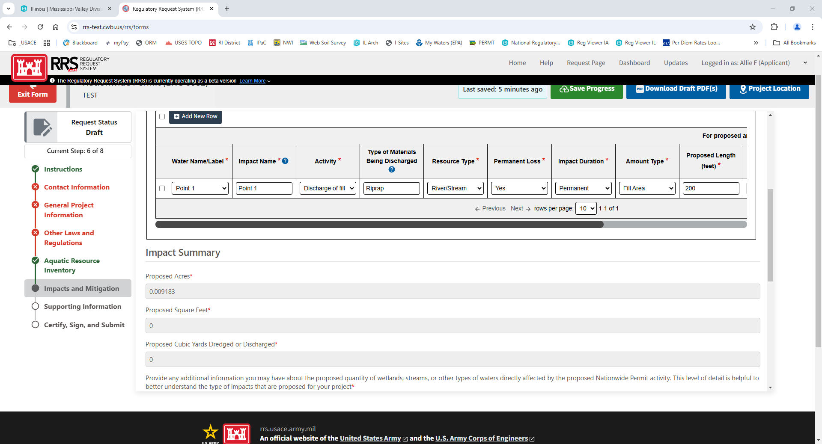
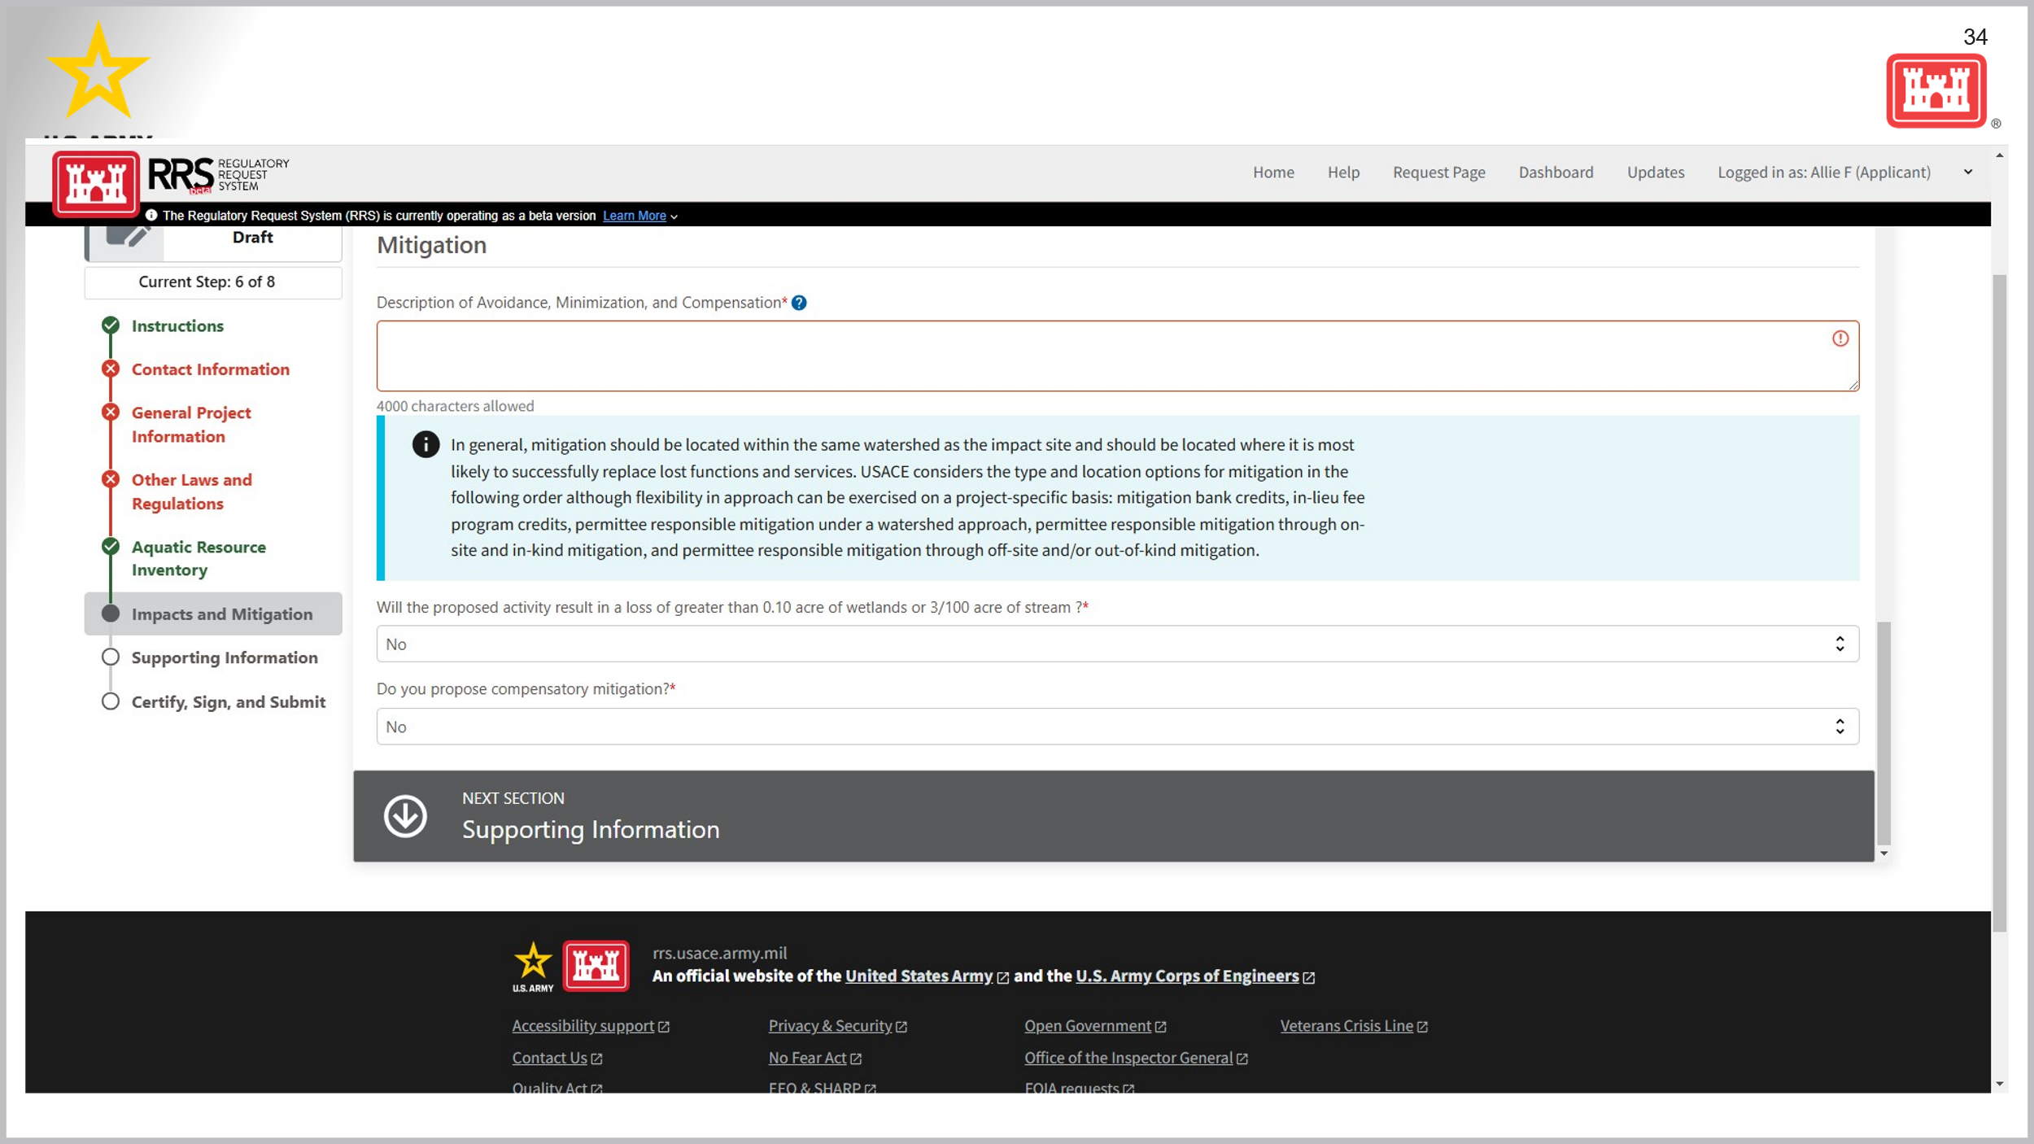
    - Supporting Information – maps, plans, plots, anything additional you can provide
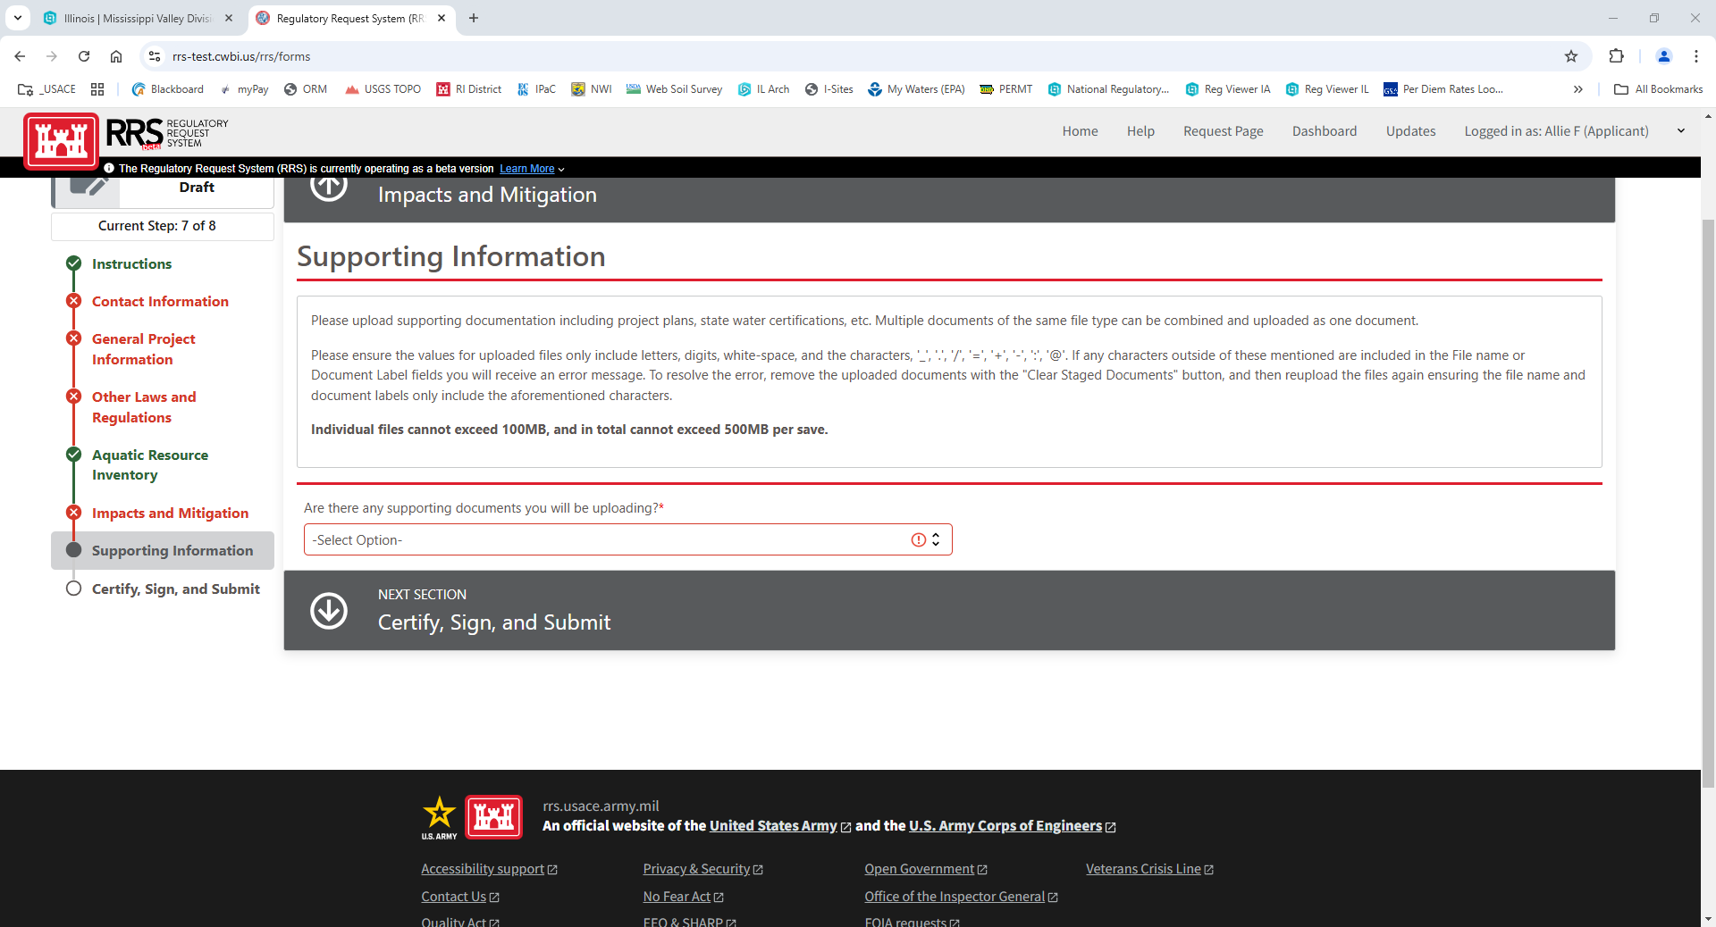
    - Certify, Sign, Submit – must complete in order to submit to USACE – will tell you what district it was submitted to (based on location of your project).
  - (See Below Photo) Follow all directions until the whole application is filled out. The site will have all green check marks on the left-hand side when the application is completed to the extent desired. Must fill out everything with an Asterisk (*) in order to “complete” the section, otherwise will show up red.
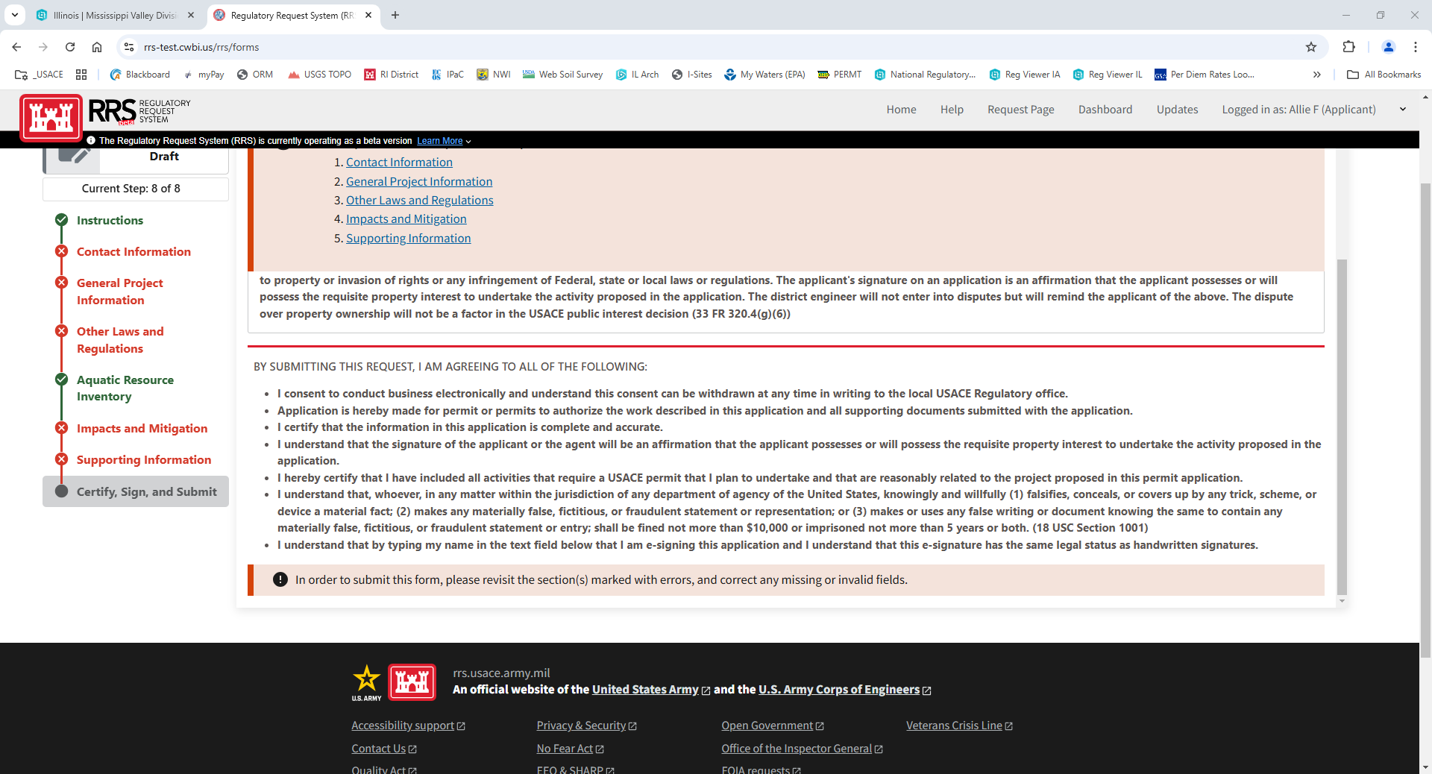
**Once you submit your application, you CANNOT change or update it. You can only edit your application when it is a draft BEFORE you submit. If your project manager from the Corps asks you for additional information later, you can submit that via RRS, email, or mail.**
**Make sure you get your state certifications as well. – Please look at the specific state “Application Instructions”**

Need Help?
If you have any questions on how to complete these, please complete the following list of items to guide you through the process.
- Please review “Regulatory Program Information,” “Permitting” and “RRS Support” based on your needs.

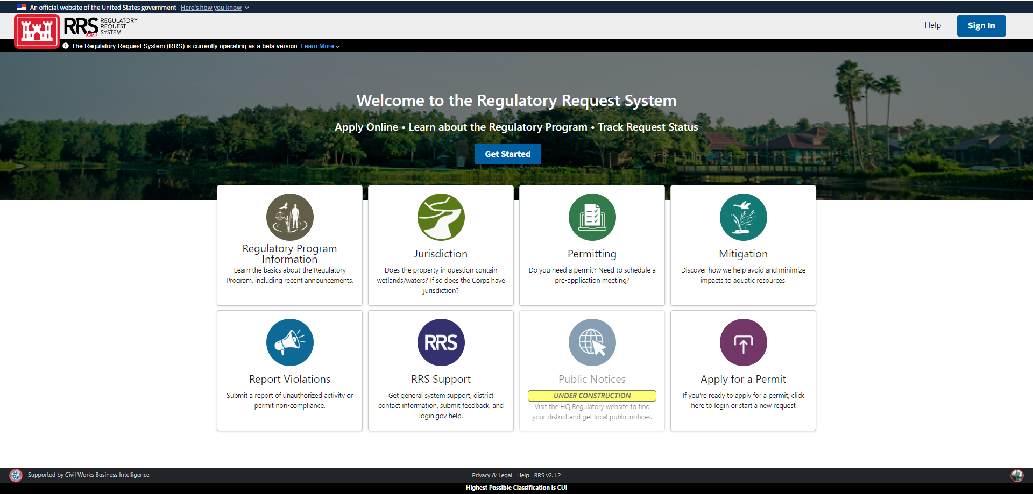

- Email iowaregulatory@usace.army.mil if in Iowa or illinoismoregulatory@usace.army.mil if in the Rock Island District Illinois or MO boundaries.
- Call 309-794-5057 (Rock Island District Regulatory Line)
If you have any issues submitting online, you may also email or mail your application/ request to the following addresses:
Email
- Iowa: iowaregulatory@usace.army.mil
- Illinois/ MO: illinoismoregulatory@usace.army.mil
Mail
U.S. Army Corps of Engineers, Rock Island
ATTN: Regulatory Branch
Clock Tower Building
P.O. Box 2004
Rock Island, IL 61204-2004

